Employee | - Benefits  - &  - Hazard Benefits
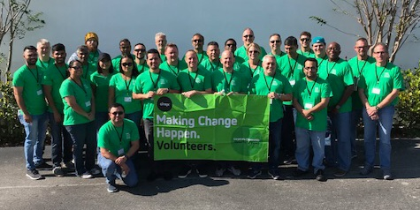  BENEFITS:  Available to All Regular Full Time Employees  Salary as negotiated at time of employment offer  After 90 days  Float Holiday 1 per year  Medical and Dental Benefits paid by Poverello at 80% of Premium (You are responsible for 20%)  401K Contribution (Up to 4% Match of your salary)  Paid Time Off Accrued at 3/Hrs per pay period  Selection of Accident, Critical Illness, Term Life, Life and/or Health Savings Account paid by you.  Short Term Disability paid by Poverello | HAZARD BENEFITS:  Available Only During the Declared Public Health Emergency as Determined by State of Florida  Additional $2.50/Hr Hazard Pay  2 Weeks Equivalent Sick Leave  Families First Coronavirus Response Act’s Family Medical Leave (EFMLA)  After 90 days  Medical and Dental Benefits 100% Paid by Poverello  4% Poverello Contribution regardless of employee contribution.  All Elected Colonial Life Benefits Paid by Poverello  Student Loan Payment or Tuition Reimbursement up to $2000/yr

