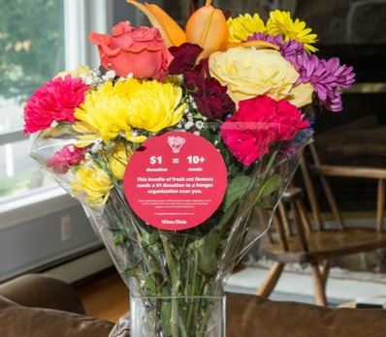

BLOOMIN’ 4 GOOD PROGRAM
Press Release

FOR IMMEDIATE RELEASE: The Poverello Center, Inc. Thomas S. Pietrogallo, MSW/LCSW, MBA 954-213-6597

The Poverello Center, Inc. Celebrates Selection as a Winn-Dixie Bloomin’ 4 Good Program Beneficiary

Wilton Manors, Florida – The Poverello Center, Inc. has been selected as a beneficiary of the Winn-Dixie Bloomin’ 4 Good Program for the month of January 2023.

The Winn-Dixie Bloomin’ 4 Good Program, which launched in October 2021, is an easy way for shoppers to give back. Every $12.99 Bloomin’ 4 Good Bouquet with the red circle sticker sold supports a hunger organization local to the Winn-Dixie in which it was purchased.

The Poverello Center, Inc. was selected as the January beneficiary by local store leadership at the Winn-Dixie located at 1625 Cordova Rd., Fort Lauderdale, FL. The Poverello Center, Inc. will receive a $1 donation for every $12.99 Bloomin’ 4 Good Bouquet purchased at this Winn-Dixie location in January.

“Flowers can make someone’s day, brighten a room or spread a smile,” said Thomas S. Pietrogallo, CEO of The Poverello Center Inc. “Now they can fight hunger too. Purchase a Bloomin’ 4 Good Bouquet at Cordova Rd. Winn-Dixie in January to help fight hunger. Every bouquet sold will feed 10+ people in need.”

The Poverello Center, Inc. is a nonprofit based in Wilton Manors, Florida. Founded in 1987, The Poverello Center, Inc. has fed your neighbors with critical and chronic illnesses. Learn more about The Poverello Center, Inc. by visiting www.poverello.org .

For more information about the Winn-Dixie Bloomin’ 4 Good Program, please visit seg.2givelocal.com.

