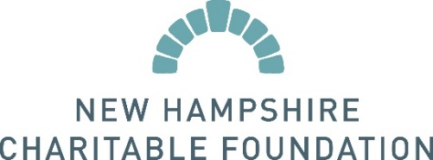
PRESS RELEASE: New Hampshire Charitable Foundation's Ronald P. Bourgeault Charitable Fund Awards Poverello Funds
FOR IMMEDIATE RELEASE
CONTACT:
Brad Barnes
Live Well Center Manager
The Poverello Center, Inc. Direct number (954) 228-8984
bbarnes@poverello.org
The Poverello Center, Inc. receives grant from the New Hampshire Charitable Foundation's Ronald P. Bourgeault Charitable Fund for general support.
The Poverello Center, Inc. recently received a $1,000 grant from the New Hampshire Charitable Foundation. The grant will help further The Poverello Center, Inc.’s mission of providing nutritious food, health services, and basic living essentials with the highest degree of understanding, respect, and love for individuals living with critical and chronic illnesses including HIV, in South Florida by helping us pay an electrician and plumber to install a new water heater for showers.
The Poverello Center, Inc. offers showers, and provides hygiene packs to about 230 people each month. Without support like that provided by New Hampshire Charitable Foundation's Ronald P. Bourgeault Charitable Fund, we wouldn’t be able to offer the simple support of a warm shower to the unhoused.
About Organization
The Poverello Center, Inc. is an award winning organization that provides nutritious food, health services, and basic living essentials with the highest degree of understanding, respect, and love for individuals living with critical and chronic illnesses including HIV, in South Florida. As the only consumer choice medically tailored grocery program member of the National Food is Medicine Coalition in Florida, Poverello serves more than 3,000 individuals and families throughout Miami-Dade, Broward, and Palm Beach Counties with over 22,000 weeks’ worth of groceries per year. The organization feeds the poor when they’re sick.
About the New Hampshire Charitable Foundation
The New Hampshire Charitable Foundation is New Hampshire’s statewide community foundation, founded in 1962 by and for the people of New Hampshire. We are the place where generosity meets the dedication and ingenuity of nonprofits and the potential of New Hampshire students. For six decades, thousands of people have entrusted their charitable resources to the Foundation, creating a perpetual source of philanthropic capital and making it possible for the Foundation to award more than $60 million in grants and scholarships every year. For more information, please visit www.nhcf.org or call 603-225-6641.

